Understanding Convection

Directions: The figure below shows a convection cell in Earth’s mantle. A convection cell is one complete loop of a convection current. Use the figure to answer the questions that follow.

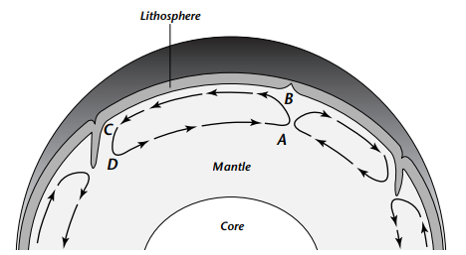

- Where does the heat come from that drives this convection current in the mantle?

- Where is the temperature of the mantle material greater, at point A or point B? Explain why.

- Where is the density of the material greater, at point B or point C? Explain why.

- What happens to the temperature and density of the material between points B and C?

- What force causes the convection cell to turn down at point C?

- What happens to the temperature and density of the material between points D and A?

- What causes the convection cell to turn up at point A?

- How do you think this convection cell might affect the crust material above it?

Convection Bottles

Model:

Observations:

Reflection Questions

A). Under what conditions could you observe convection cells forming inside the jar? How did they move?

B). What happened to the fluid near the upper surface of the jar?

