Name ______ Date_______________________ Hr_________
The Theory of Plate Tectonics

Understanding Main Ideas
Label each diagram by writing the type of plate boundary it shows.

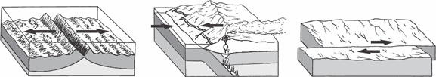

1. 2. 3.

4. Describe what happens when
(a) two plates carrying oceanic crust collide:

(b) two plates carrying continental crust collide:

(c) a plate carrying oceanic crust collides with a plate carrying continental crust:

5. Explain what force caused the movement of the continents from one supercontinent to their present positions.

