Name_______________________________________________ Date_________________________ Hr_________

The Lunar Cycle

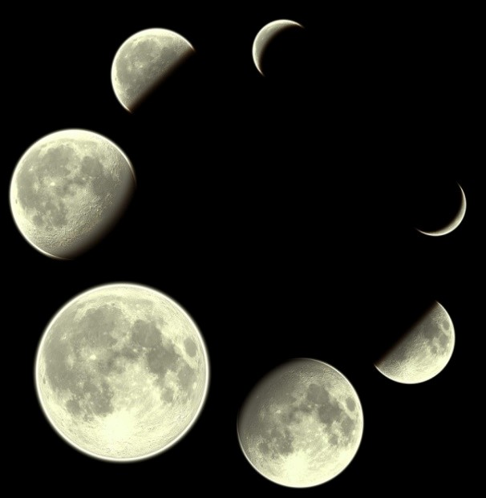
1 Rising into the dark sky, a giant yellow Moon casts an eerie glow over sleeping Earth. It does not produce its own light. The bright Moon, however, acts like a mirror by reflecting the Sun's light to Earth. Have you looked at this round object during a night like this? You may have noticed that you can see the entire face. Known as a full moon, this is just one of the eight phases of the Moon.

2 Have you ever noticed that the shape of the Moon always seems to be changing? One night, the Moon may appear like the one described above, round and full. On another night, the Moon may be the shape of a clipped toenail, called a crescent moon. Sometimes there might not be a Moon visible at all. What is happening? The reason may surprise you. The Moon, like many things on Earth, has a cycle. Think of this
cycle as a continuous circle that repeats itself over and over again. Taking almost 28 days to complete, the Moon revolves around Earth in its orbital path.

3 As the Moon revolves around Earth, its position relative to the Sun changes. Think back to how the Moon is not producing its own light, but is reflecting the light of the Sun. We are watching from Earth's surface. Why do we sometimes see a full moon and sometimes see only a portion of the illuminated moon? Read on to find out what is actually going on.

4 When a light shines on a sphere, half of the sphere receives light and the other half does not. This occurs because light rays travel in a straight line. They cannot bend around to hit the back side of the sphere. The back half of the sphere remains dark, in the shadow of the front half of the sphere. Try a little experiment to demonstrate this. Shine a bright flashlight on a golf ball or small orange. You should see a clear line between the illuminated side and the shadowed side. Now try moving around to see your “Sun-Moon“ model from different viewpoints. Think about how this change in viewpoint might explain why you also see varying illuminated portions, or phases, of the Moon.

5 The first phase of the Moon's cycle is called a new moon. During a new moon, the Sun's light is not shining on the side of the Moon that is facing Earth. From Earth, you only see the shadowed side of the Moon. When this happens, it appears as if there is no Moon present in the sky at all. As the Moon continues to travel around Earth, it now seems to be growing. It lights up like a sliver of a clipped toenail on its right side. The Moon has entered its second phase, called a waxing crescent. Waxing means that the amount of the illuminated moon's surface seen from Earth is increasing. Keep in mind that the amount of surface being illuminated is not changing. Only Earth's point of view changes. These are like the changes you could see by moving to a different position with your “Sun-Moon” model using the flashlight.

6 A first quarter moon is the next phase. In this phase, the right half of the Moon is illuminated by the Sun. In its next phase, the Moon is called a waxing gibbous moon. Almost all of the Moon can be seen in the night sky during this phase.

7 We have now reached the full moon. The entire face is visible. We have traveled more than halfway through the Moon's phases. After the Moon hits the full moon phase, it appears to start shrinking. During these phases, the term “waning” is used. Waning means that the portion of illuminated moon surface visible from Earth decreases with each passing phase. In the waning gibbous moon phase, almost all of the surface is visible. Next comes the last quarter moon phase, with exactly half of the left lunar face being visible. This phase is followed by a waning crescent, and then we are back to a new moon, bringing us full circle. The Moon has finished its revolution around Earth.

8 As you gaze up into the night sky, the Moon might not seem so mysterious any more. The changing shapes are not really changing the Moon. The reflected light that we are able to see changes as the Moon revolves around Earth. This makes the Moon appear to magically grow or shrink. These eight phases keep repeating to make the lunar cycle.

