Name___________________________________________ Date_______________ Hr_____

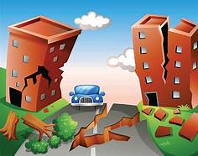

**Earthquake Crossword**

